Analysing and Cleaning Data
Contents
1 Preparing the Data 1
1.1 Region Table 1
1.2 Population Table 2
1.3 Populate Table Version 2 7
1.4 OLAP Commands 10
1.5 Missing Data 11
2 Missing Values 11
2.1 Residents Pay Reshaping 12
2.2 Cleaning Data 12
2.2.1 Apply the Average value 13
2.2.2 Apply the Difference 15
2.2.3 Remove records 16
2.2.4 Use Nulls 18
2.3 Import Resident Pay 18
3 Summary 20

Preparing the Data
The last workbook looked at how to load an Excel spreadsheet into Oracle. Very little preparation was done on the data, however, when working with found data – that is, data found elsewhere, you have very little control over how the data was produced or what format it is in, which may not suit your purposes.
Let’s revisit our REGION and POPULATION tables. First login to Oracle using SQL*Developer – see Workbook 1 for details on how to do this.

Region Table
Right Click on the Tables (Filtered) option in the Connections pane and click on REGION. Then click on the Data option, which can be found along the top:
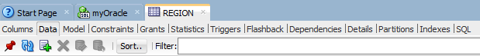
If you examine the data, LOCAL_AUTHORITY_CODE_2 and COUNTY_NAME2 seem to be duplicates of the LOCAL_AUTHORITY_CODE and COUNTY_NAME columns:
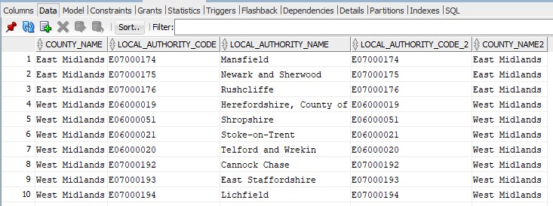
Figure 1-1 Sample Region Data
Run some SQL code in a worksheet to check if this is the case:
SELECT * FROM REGION
WHERE LOCAL_AUTHORITY_CODE <> LOCAL_AUTHORITY_CODE_2;
SELECT * FROM REGION
WHERE COUNTY_NAME <> COUNTY_NAME2;
Both commands should return no rows, so the surplus columns could be removed since they do not add any extra information. The ALTER TABLE command can be used to do this:
ALTER TABLE REGION
DROP COLUMN LOCAL_AUTHORITY_CODE_2;
ALTER TABLE REGION
DROP COLUMN COUNTY_NAME2;
You may need to refresh the Tables list to see the effect on the REGION table.
- If you are feeling brave, you could use the Developer tool to rename or drop objects, such as tables, or columns. To do this, right click on the required column (or table) and select the required command instead.
The REGION table should now just have 3 columns:
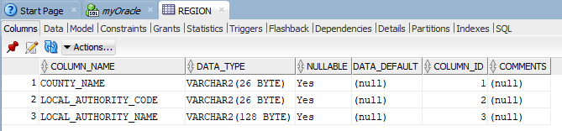

Population Table
Next browse the Population table, it does not appear to have any duplicate columns:
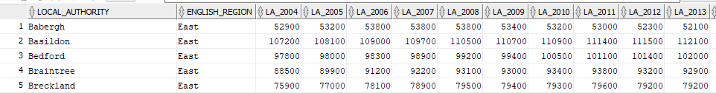
There are a number of columns that contain the populations for each year, LA_2004, LA_2005, etc. These column headings contain values that you might want to include in any analysis and makes it cumbersome to write SQL to include them. This particular spreadsheet could have been generated from a cross tabulation analysis and really we want to reverse-engineer the data so that we can include the years as values too, rather than as column headings.
So rather than this:
local_authority | English Region | 2004 | 2005 | 2006 | Etc..
Babergh | East | 52,900 | 53,200 | 53,800 | ---
We want the data to appear like this
local_authority | English Region | Year | Figure
Babergh | East | 2004 | 52,900
Babergh | East | 2005 | 53,200
Babergh | East | 2006 | 53,800
This can be achieved in a number of ways, such as using Python, Java or other programming languages to manipulate the data as required.
Since the data is not too large, Excel can be used to manipulate this:
- Use Excel to open the modified spreadsheet from Workbook 1, e.g., “Population Estimates Updated”. This should be the version where you removed some lines from the start and end of the data worksheet.
- Create a copy of the Data Worksheet. Right-click on the Data tab found at the bottom of the spreadsheet and select Move or Copy….
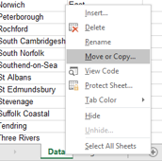
Make sure the Create a copy option is clicked and press OK:
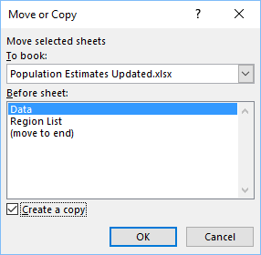
- This will create a new copy of the data worksheet called Data (2), rename this to DataUpdate
- If you examine any of the values listed under the column “English Region” you will see they are actually lookup values from the Region List worksheet. We can therefore remove this column from this worksheet, since we can get this information by joining the tables in the database. We also do not want this column in our pivot table, since it is a different data type (character) to the numerical data found in the population figures.
To do:
- Select the “English Region” column, press right-click and select Delete.
- Ensure there is no informational data at the start or end of the worksheet. E.g., the first row should be the column headings and the last row should be data for York. If there is extra information, such as the title “Population estimates - local authority based by five year age band” at the start, or Column Totals at the end, remove these rows – see last workbook for information.
To summarise your first rows should look like this:
And last rows:
Now the data is in an appropriate format, we can create a “reverse pivot table” using the PivotTable Wizard and PivotChart Wizard:
- Press Alt+D then P to access the wizard and select “Multiple consolidation ranges”:
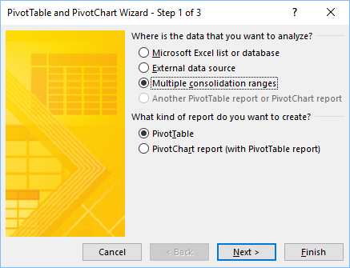
- Press Next and then select “I will create the page fields”:
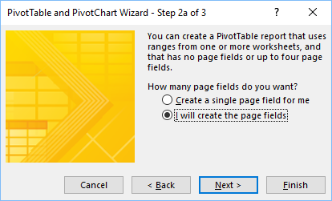
- Press Next again, then it will ask for the Range of values. For this you need to return to the worksheet and use the mouse to select all the columns and rows (for example: DataUpdate!$A$1:$O$327).
- Press Add so that the range values appear under All ranges:
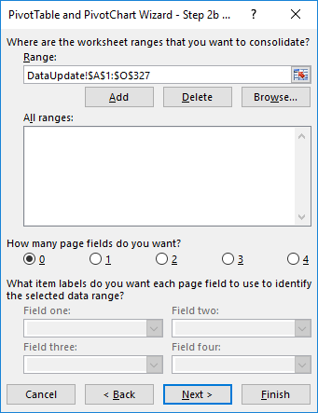
- Leave the other options as above and press Next. You will then be asked whether to put the PivotTable into a new or existing worksheet. Select New worksheet and then Finish:
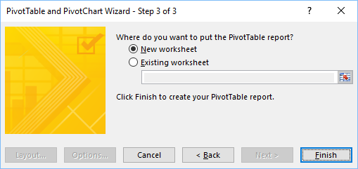
You will then be presented with a new worksheet that is similar to this:
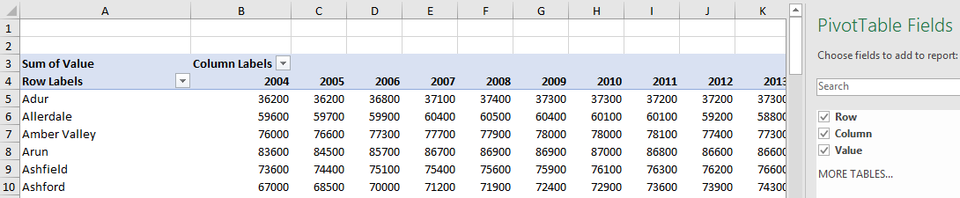
Unselect the Row and Column buttons seen on the right-hand side and this will reduce the data to just one value:
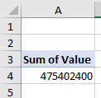
The data has not been lost! Double-click on the value, for example, the value seen in A4 above and the data will appear as below:
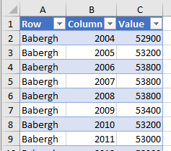
This data now can be reloaded back into Oracle.
Before doing this, give the column headings more meaningful names. Rename as follows:
Row | Local_Authority
Column | Pop_Year
Value | Figure
So the first row should look like this:
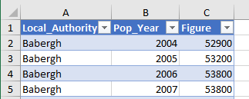
This data will have been put into a new worksheet, typically called Sheet3, rename this to PopData. You can do this by double-clicking on the worksheet name at the bottom of the spreadsheet and then type in the new name. Save the spreadsheet and exit Excel.

Populate Table Version 2
Start Oracle SQL*Developer – see Workbook 1 for details.
Remember to reconnect to the database.
The previous Population table can be dropped since it is not in a good format.
To do using Developer right-click on the Population table, which can be found under the list of tables under your connection name:
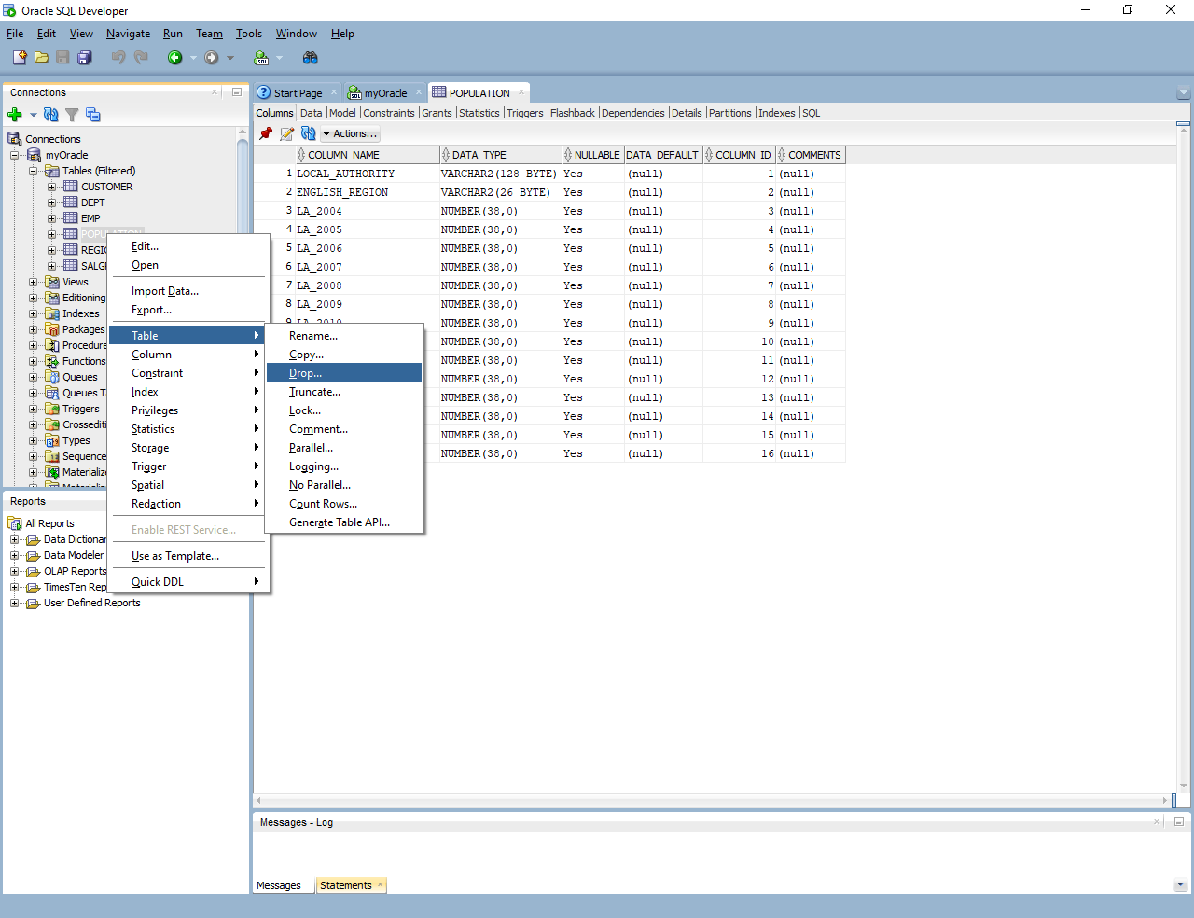
Select Table, then Drop. This is similar to carrying out the SQL DROP TABLE command.
It will then ask you to confirm the schema and table name, press Apply to drop the table:
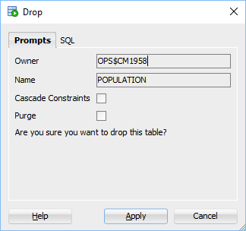
The system should confirm that it has been dropped:
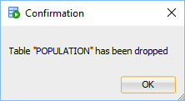
Next use the Tables (Filtered)>Data Import command to import the new PopData worksheet:
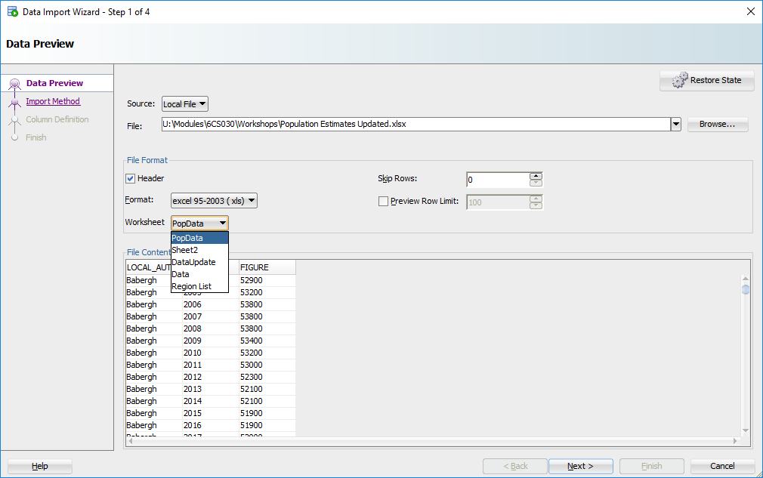
Follow the steps seen previously in Workbook 1 to load the data. Call this table POPULATION again. This time there will be no issues with the column names starting with a number. Make sure the size of the Local_Authority column is more than 28 characters. Pop_year and Figures should be numbers, the maximum size (precision) can be 4 for year and 6 for figures.
The new table will have a similar structure to this:
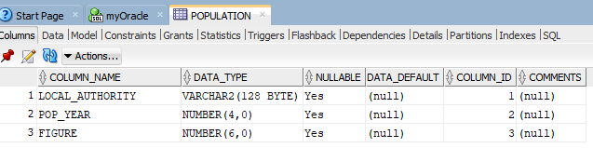
And the data will now be in this format:
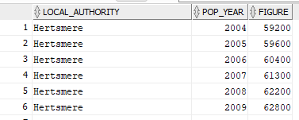
This makes it far easier to do any statistical analysis on the data, for example, find the average population by year:
SELECT POP_YEAR, ROUND(AVG(FIGURE),2) AS AVG_POP
FROM POPULATION
GROUP BY POP_YEAR
ORDER BY POP_YEAR;
Or by authority:
SELECT LOCAL_AUTHORITY, ROUND(AVG(FIGURE),2) AS AVG_POP
FROM POPULATION
GROUP BY LOCAL_AUTHORITY
ORDER BY LOCAL_AUTHORITY;
To retrieve the county name we deleted earlier:
SELECT COUNTY_NAME, LOCAL_AUTHORITY_NAME, POP_YEAR, FIGURE
FROM REGION R, POPULATION P
WHERE R.LOCAL_AUTHORITY_NAME = P.LOCAL_AUTHORITY
ORDER BY COUNTY_NAME, LOCAL_AUTHORITY, POP_YEAR;

OLAP Commands
In SQL additional support for OLAP (On-Line Analytical Processing) systems has improved support for carrying out statistical analysis. For example, the GROUP BY clause has been enhanced to include either ROLLUP or CUBE.
These new options provide the kinds of summary information that is used in Data Warehouses, or for cross tabulation analysis. You can use CUBE and ROLLUP to generate summary information so you will not have to write a separate query for each type of summary information you are interested in.
For example, examine the information generated by this:
SELECT COUNTY_NAME, LOCAL_AUTHORITY_NAME, ROUND(AVG(FIGURE),2) AS POP_FIG
FROM REGION R, POPULATION P
WHERE R.LOCAL_AUTHORITY_NAME = P.LOCAL_AUTHORITY
GROUP BY ROLLUP(COUNTY_NAME, LOCAL_AUTHORITY_NAME)
ORDER BY COUNTY_NAME;
Cube generates slightly different results:
SELECT COUNTY_NAME, LOCAL_AUTHORITY_NAME, ROUND(AVG(FIGURE),2) AS POP_FIG
FROM REGION R, POPULATION P
WHERE R.LOCAL_AUTHORITY_NAME = P.LOCAL_AUTHORITY
GROUP BY CUBE(COUNTY_NAME, LOCAL_AUTHORITY_NAME)
ORDER BY COUNTY_NAME;
For our purposes they can be used to get a feel for the data and to check if there are any outliers, or issues in the data.

Missing Data
One thing to check is if we have all the authorities in our population table:
SELECT LOCAL_AUTHORITY
FROM POPULATION
WHERE LOCAL_AUTHORITY NOT IN
(SELECT LOCAL_AUTHORITY_NAME FROM REGION);
This should return no rows, which should be expected unless something has gone wrong with our import command. How about checking if all authorities are covered from our Region table:
SELECT LOCAL_AUTHORITY_NAME
FROM REGION
WHERE LOCAL_AUTHORITY_NAME NOT IN
(SELECT LOCAL_AUTHORITY FROM POPULATION);
This time a number of authorities are returned. Further investigation shows these are all values from one area:
SELECT LOCAL_AUTHORITY_NAME, COUNTY_NAME
FROM REGION
WHERE LOCAL_AUTHORITY_NAME NOT IN
(SELECT LOCAL_AUTHORITY FROM POPULATION);
So now we know that Welsh data is missing from the datasets. It is always important to know our data!

Missing Values
The data in the Population spreadsheet has few issues in terms of missing values, but this may not always be the case.
Download the Resident Pay spreadsheet from Canvas and open it in Excel and you will notice that some values are either #, - or ! instead of numeric values.
The key at the bottom of the spreadsheet shows these represent the following cases:
# These figures are suppressed as statistically unreliable.
- These figures are missing.
! Estimate and confidence interval not available since the group sample size is zero or disclosive (0-2).
We will investigate whether anything can be done about these missing values.

Residents Pay Reshaping
Before carrying out any changes to the values reshape the Data worksheet so it just contains the pay information, removing the information about the data at the start and end:
- create a copy of the Data worksheet, call this DataUpdate. (It is always a good idea to keep a copy of the original data).
- Now remove the extra information at the start and end of the worksheet, that is remove the first eight lines so that the first line contains the column headings.
- Rename the first column: local authority: district / unitary (prior to April 2015) to local_authority
- Go to the end of the worksheet and remove the Column Total row and the following rows that give details about the key. The last row should contain the data for York.
At the end of this, the DataUpdate worksheet should start with the column headings and end with the data for York (327 rows in total).
As with the Population data, the pay figures are shown across for each year:
local_authority | 2004 | 2005 | 2006 | Etc….
Babergh | 21,782 | 21,214 | 23,140 | -----
Basildon | 24,908 | 24,037 | 25,568 | -----
Instead the year data should be included in the values, for example:
local_authority | Year | Figure
Babergh | 2004 | 21,782
Babergh | 2005 | 21,214
Babergh | 2006 | 23,140
Basildon | 2004 | 24,908
Basildon | 2005 | 24,037
Basildon | 2006 | 25,568
Carry out the steps seen in Part 1.2 to create a Pivot table, which should give the following count:  And will should result in a new worksheet with 4891 rows.  Call the new worksheet Resident_Pay. | 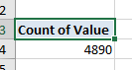
Rename the column headings to Authority, Year and Pay:
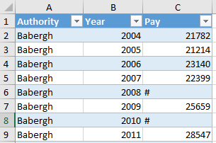

Cleaning Data
Browse the data in the new Resident_Pay worksheet. There is no obvious pattern to the missing data, so it is not a simple matter to change these. If we import the data into Oracle, or any other type of DBMS, the numerical data will be loaded as VARCHAR, so making statistical analysis difficult.
Some solutions could include:

Apply the Average value
Babergh has three missing values. Visualising the data can help decide what to do. To create a chart:
- select the Year and Pay rows for just Babergh
- click on Insert from the main menu
- then click on Recommended Charts 
- Pick a chart that helps analyse the data.
Note, the charts generated appear to be depended on what version of Excel you are using. If your charts do not resemble below, then omit the steps below for creating a chart. It is more important to carry out the data cleansing steps. See the addendum if you are using an older version of Excel.
For example, a Line Chart shows the # as three distinct dips in the values:
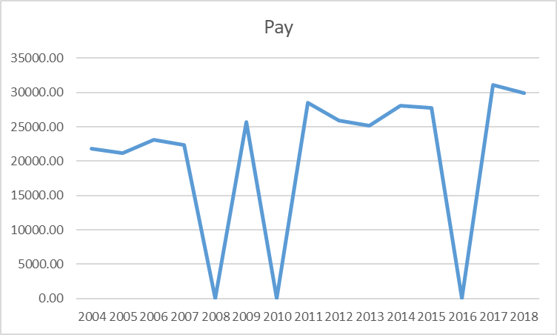
Whilst a Clustered Column just omits them and is probably more suitable:
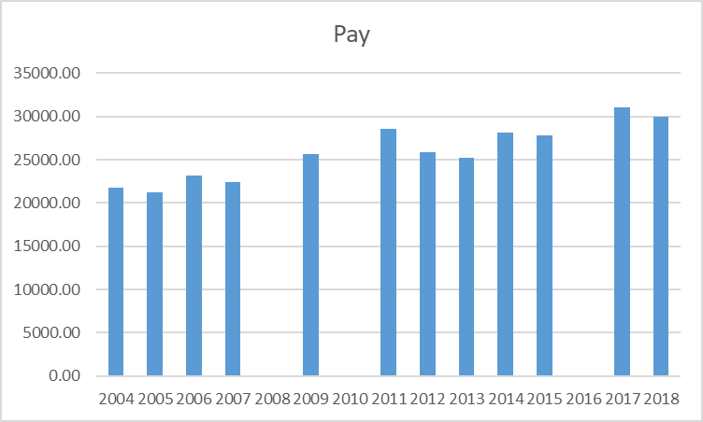
This chart also shows that the data fluctuates over the years, so one solution could be to replace the hash values with the average figure.
In cell D16 type in the following formula:
=AVERAGE(C2:C16)
Cells C2 to C16 should be the values for the Babergh area only:
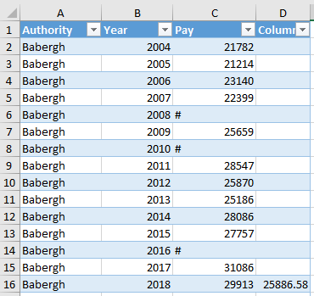
The value generated should be 25886.58. Copy this value and then right-click in cell C6, then select Paste Options and Values to replace the # with this value. Repeat this for cells C8 and C14:
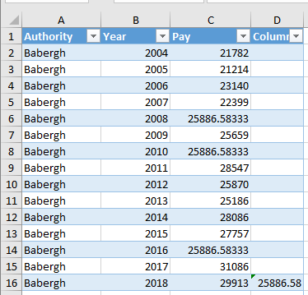
The pay for these columns may default to 4 decimal places as seen above. This can be changed by selecting the whole Pay column, right-click, then select Format Cells>Number and change the Decimal Places to 2.
Review other areas to see if this technique would be suitable, for example, Central Bedfordshire is missing the years 2004-2007 and Forest Heath is missing 2008, 2010, 2014 and 2015.
To do:
- For Central Bedfordshire, calculate the average for the years 2008-2018 and replace the dashes with the generated results.
- For Forest Heath, calculate the average for the years 2004-2018 and replace the hashes with the generated results.
- Repeat this for other suitable areas, such as County Durham (2004-7), Wilshire (2004-7), Cheshire East (2004-7), Chester West and Chester (2004-7) and Shropshire (2004-7) replacing either the dash or hash with the average for that area.
For these you can calculate the average by typing =AVERAGE( into an empty cell, then select the required values and press Enter – make sure you select the correct values for the area you are interested in.
2004 to 2007 frequently has missing data, so could include problems during that time.

Apply the Difference
Some areas are just missing one value, for example, Braintree is just missing 2015:
Braintree | 2014 | 31331.00
Braintree | 2015 | #
Braintree | 2016 | 31481.00
If we create a chart for this area, it appears to be steadying increasing overall:
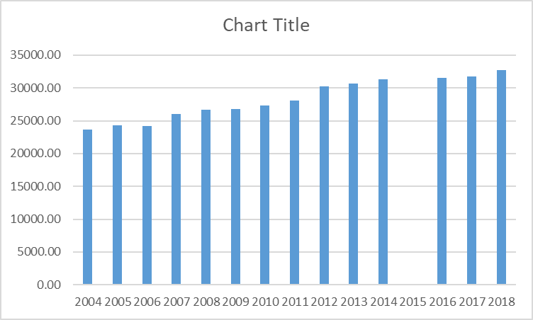
One solution could be to apply the median of the values for 2014 and 2016, that is, the midpoint of the values for 2014 and 2016. In the cell with the hash (C58) type in the following:
=(MEDIAN(C59, C57))
The result should generate: 31406.00
If you look at your chart this does not produce data that is out of sync with the other values:
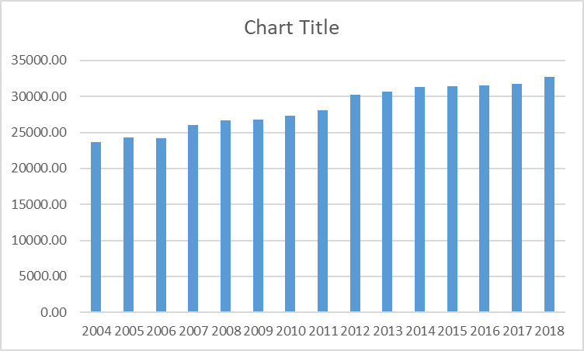
To do:
- Investigate other areas where this technique may be suitable, for example, Broxbourne (2012), Cambridge (2005), Fenland (2008), Harlow (2015), Hertsmere (2014) and Ipswich (2005). Apply the median of the two values surrounding the missing year.
- The format for the median function is: =MEDIAN(cell1, cell2) where cell should be replaced by the name of the cell containing the preceding and succeeding values

Remove records
Sometimes it is not feasible to calculate the missing values. For example, look at the rows for Isles of Scilly:
Isles of Scilly | 2004 | -
Isles of Scilly | 2005 | !
Isles of Scilly | 2006 | !
Isles of Scilly | 2007 | -
Isles of Scilly | 2008 | !
Isles of Scilly | 2009 | !
Isles of Scilly | 2010 | #
Isles of Scilly | 2011 | #
Isles of Scilly | 2012 | #
Isles of Scilly | 2013 | !
Isles of Scilly | 2014 | #
Isles of Scilly | 2015 | #
Isles of Scilly | 2016 | #
Isles of Scilly | 2017 | #
Isles of Scilly | 2018 | #
It contains no values for any year, so these rows can be removed completely. If this island was important to the new system you would have to investigate other mechanisms for obtaining the data.
West Somerset also has a lot of missing values:
West Somerset | 2004 | #
West Somerset | 2005 | #
West Somerset | 2006 | #
West Somerset | 2007 | #
West Somerset | 2008 | #
West Somerset | 2009 | #
West Somerset | 2010 | #
West Somerset | 2011 | #
West Somerset | 2012 | #
West Somerset | 2013 | #
West Somerset | 2014 | 20689.00
West Somerset | 2015 | 30860.00
West Somerset | 2016 | #
West Somerset | 2017 | #
West Somerset | 2018 | #
Using average or median is not likely to produce meaningful results, so in this case remove the rows where the figure contains a # - basically just leave the 2 rows for 2014 and 2015.
Other areas that have large amounts of missing data include the City of London:
City of London | 2004 | #
City of London | 2005 | #
City of London | 2006 | #
City of London | 2007 | #
….
So remove all the rows for the City of London.
Kensington and Chelsea also has a lot of missing years:
Kensington and Chelsea | 2004 | #
Kensington and Chelsea | 2005 | #
Kensington and Chelsea | 2006 | #
Kensington and Chelsea | 2007 | #
Kensington and Chelsea | 2008 | 43841.00
Kensington and Chelsea | 2009 | #
Kensington and Chelsea | 2010 | 46143.00
Kensington and Chelsea | 2011 | #
Kensington and Chelsea | 2012 | 41047.00
Kensington and Chelsea | 2013 | 45497.00
Kensington and Chelsea | 2014 | 45493.00
Kensington and Chelsea | 2015 | #
Kensington and Chelsea | 2016 | #
Kensington and Chelsea | 2017 | #
Kensington and Chelsea | 2018 | #
So remove the rows where there is a hash in the Pay column.

Use Nulls
One final solution is to replace the non-numerical values with null values. One thing to consider is that nulls can affect the results of any statistical analysis.
Press Ctrl+F to bring up the Find and Replace Window:
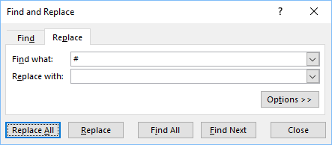
Put # in the Find what: box and nothing at all in the Replace with: box. It is important not to put a space in the latter box. Next click on Replace All.
Repeat this for any dashes (-) or exclamation marks (!)
The Pay column show now either contain numerical data or a null value.

Import Resident Pay
Return to the Oracle SQL*Developer tool and import this cleaned version of the data – make sure the Resident_Pay worksheet is selected.
Call the table RESIDENT_PAY
When you get to Step 3, ensure only the first 3 columns are selected:
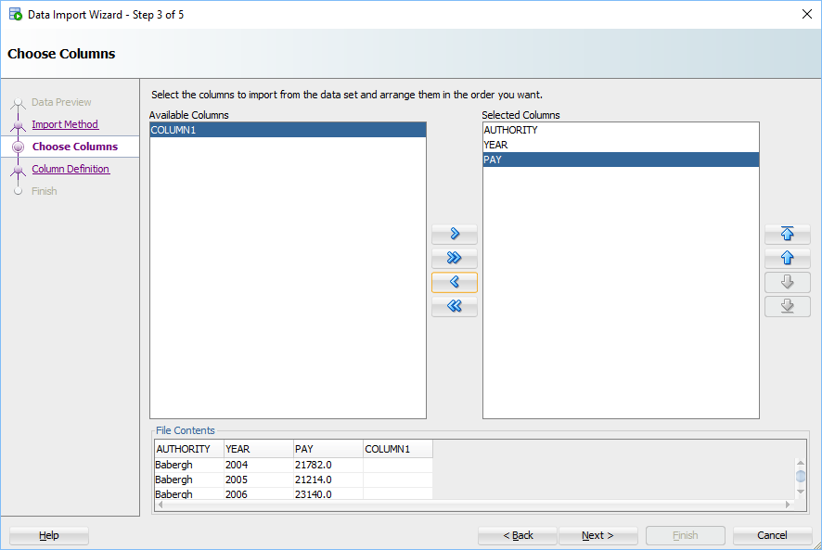
You may have other columns from calculating the average figures.
At Step 4, the number formatting in Excel will not have carried over, so some of the averages will have created large decimal places:
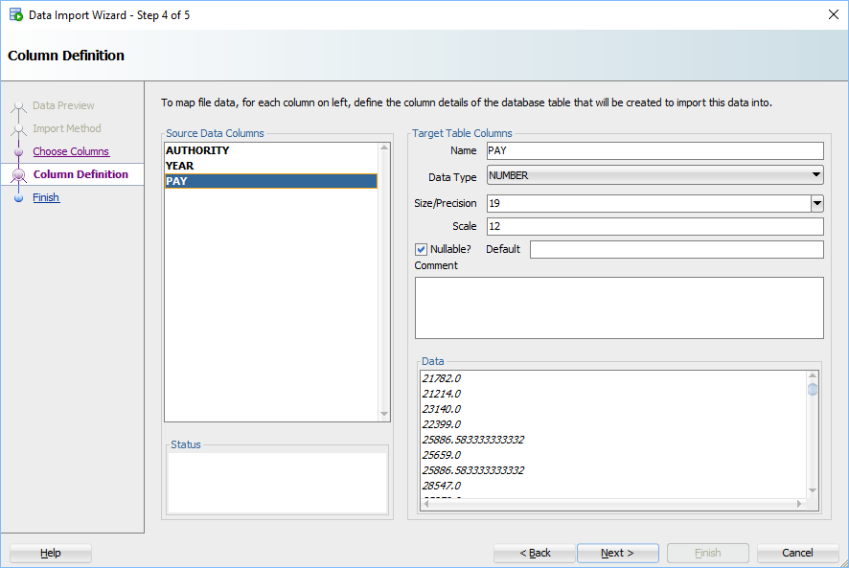
This has the effect of making the Size/Precision very large, since it will include the decimal places (Scale). Reduce the Scale to 2 and the Size/Precision to 9.
The Authority and Year columns should not allow null values, so ensure the Nullable box is not ticked for them, but it should be for Pay since we have introduced nulls for some of the missing values.
Check the Size/Precision for AUTHORITY. If it has been set to a large size, such as 128, reduce this to 40:
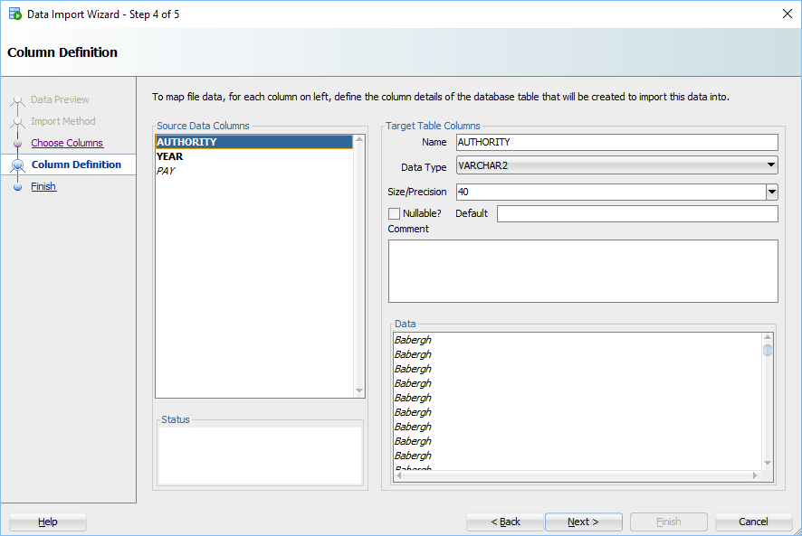
Refresh the table list and have a look at the Resident_Pay table:
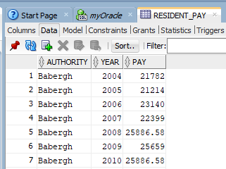
Check that the pay field does contain null values:
SELECT * FROM RESIDENT_PAY WHERE PAY IS NULL
ORDER BY AUTHORITY, YEAR;

Summary
This workbook has looked at some cleaning methods for working on found data. Unfortunately, there is no one method that can be applied to all the missing values, which would make life simpler.
In a real system it is important to document what changes have been made, since this could impact any future results produced on this data. Keeping an audit trail is important for the provenance of the data.

